
MEMORANDUM
OF

UNDERSTANDING
Between
Department of Telecommunications (GOVERNMENT OF INDIA)

And
Bharat Sanchar Nigam Ltd.
For the Year 2014-15

MEMORANDUM OF UNDERSTANDING

PART-I

VISION / MISSION AND OBJECTIVES

VISION:
- Be the leading telecom service provider in India with global presence
- Create a customer focused organization with excellence in customer care, sales and marketing
- Leverage technology to provide affordable and innovative telecom services / products across customer segments

MISSION:
- Be the leading telecom service provider in India with global presence
  - Generating value for all stakeholders – employees, shareholders, vendors & business associates
  - Maximizing return on existing assets with sustained focus on profitability
  - Becoming the most trusted, preferred and admired telecom brand
  - To explore International markets for Global presence
- Creating a customer focused organization with excellence in sales, marketing and customer care
  - Developing a marketing and sales culture that is responsive to customer needs
  - Excellence in customer service-”friendly, reliable, time bound, convenient and courteous service”
- Leveraging technology to provide affordable and innovative products/services across customer segments
  - Offering differentiated products/services tailored to different service segments
  - Providing reliable telecom services that are value for money
- Providing a conducive work environment with strong focus on performance
  - Attracting talent and keeping them motivated
  - Enhancing employees skills and utilizing them effectively
  - Encouraging and rewarding individual and team/group performance
- Establishing efficient business processes enabled by IT
  - Changing policies and processes to enable transparent, quick and efficient decision making
  - Building effective IT systems and tools

OBJECTIVES:
- To be the Leading Telecom Services provider by achieving higher rate of growth so as to become a profitable enterprise.
- To provide quality and reliable fixed telecom service to our customer and thereby increase customers confidence.
- To provide customer friendly mobile telephone service, with focus on Value added service and data services, of high quality and play a leading role as GSM operator in its area of operation.
- Strategy for:
- Leveraging the human resources
- Providing greater customer satisfaction
- Contribute towards:
- Broadband customer’s base in India as envisaged in National Telecom Policy 2012.
- Providing broadband connectivity to 2.5 lakhs Village Panchayats as per Government policy
- To leverage the existing infrastructure of BSNL for facilitating implementation of other government programmes and initiatives particularly in the rural areas.
- To look for the opportunity of possible expansion of BSNL footprint globally by exploring international telecom developing markets such as Africa.

PART-II

EXERCISE OF ENHANCED AUTONOMY AND DELEGATION OF POWERS

- BSNL exercises various powers delegated under Mini-Ratna Category-I Enterprise as and when need arises.

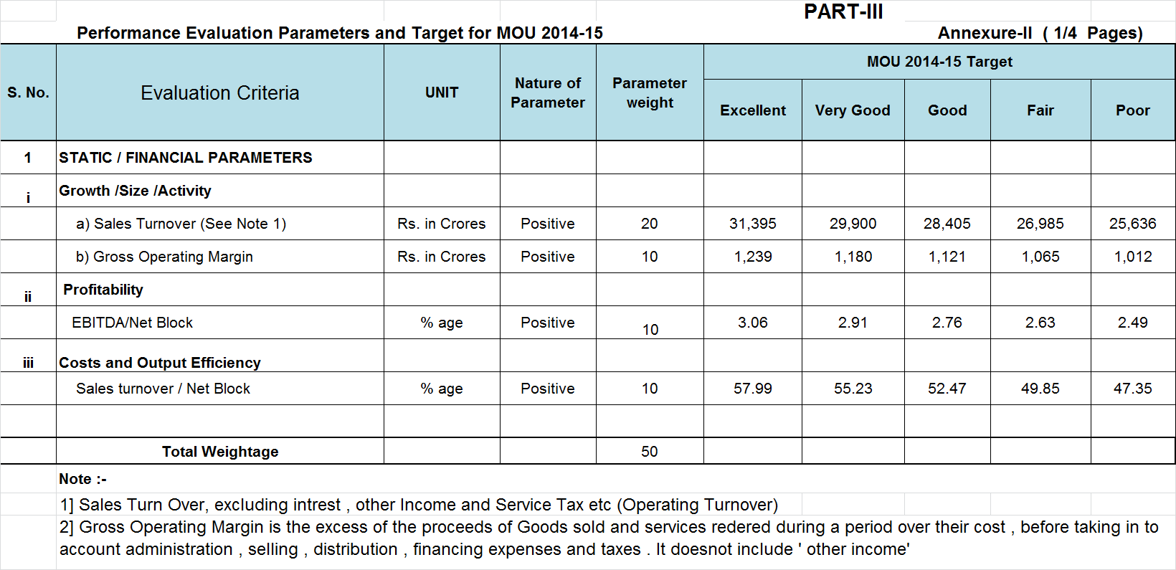
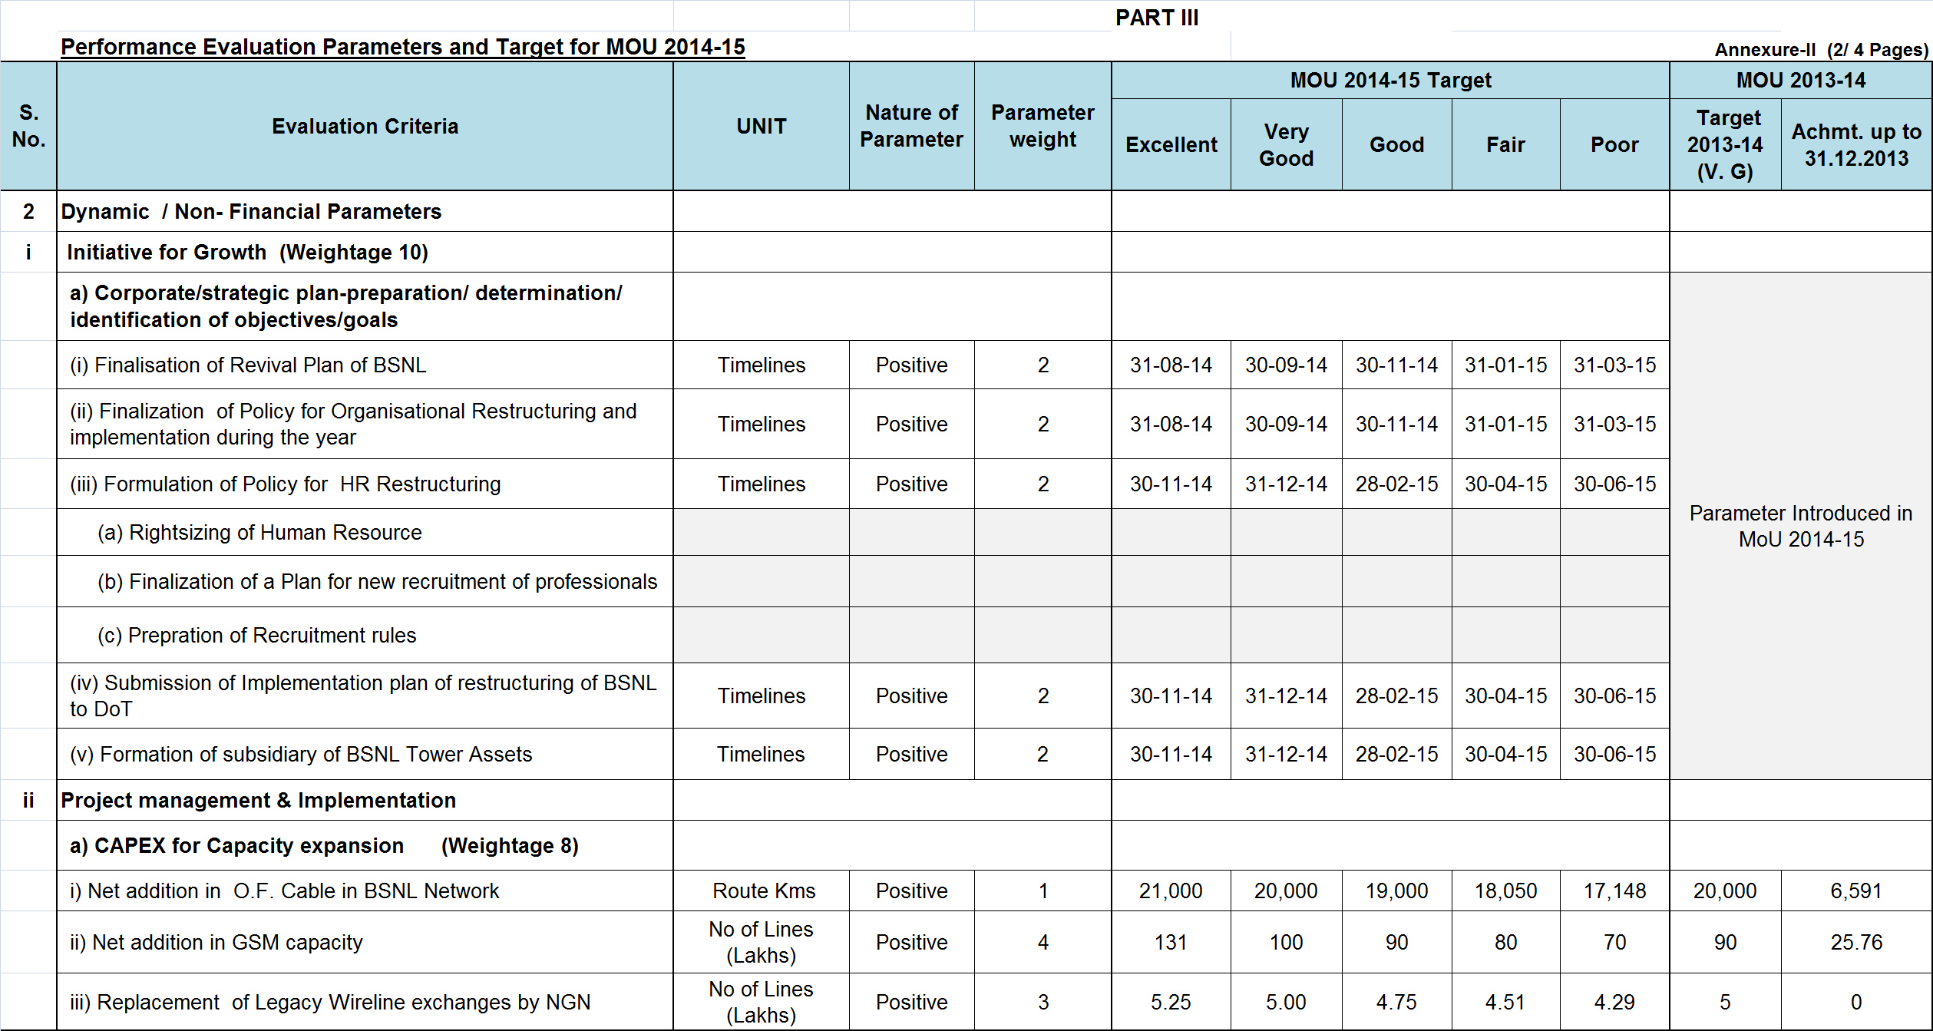
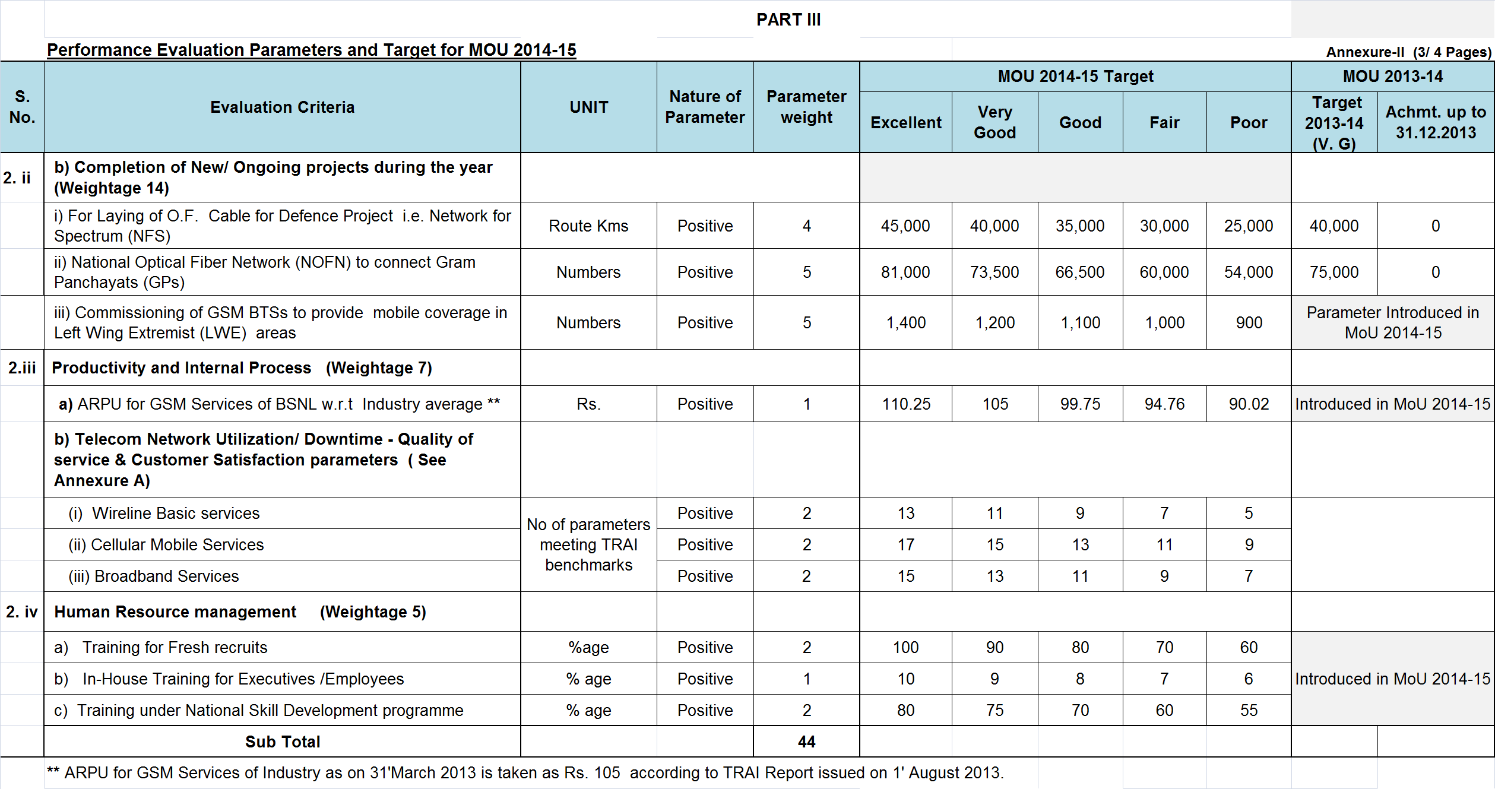
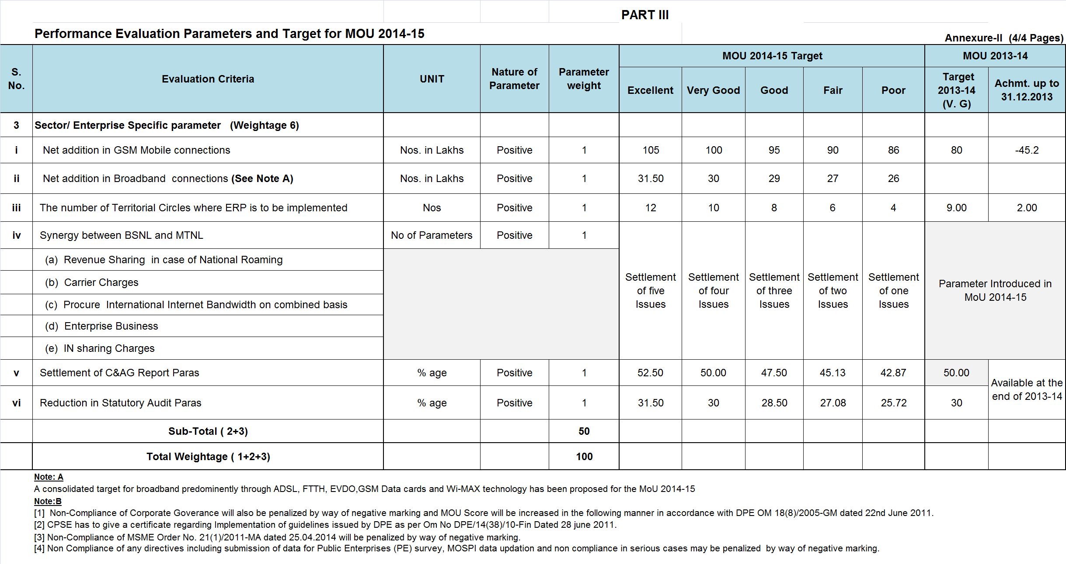
PART-IV
COMMITMENT/ASSISTANCE FROM THE
DEPARTMENT OF TELECOMMUNICATION,
GOVT.OF INDIA

Government shall endeavor to assist BSNL in the following matters:
- The DOT will get the approval of the competent authority to Refund upfront BWA Spectrum License fee to BSNL
- The DOT will finalize the Revival Plan and support to BSNL efforts in restructuring and reviving the CPSE
- The DOT will assist in appointment of Non-official Directors (NOD’s)

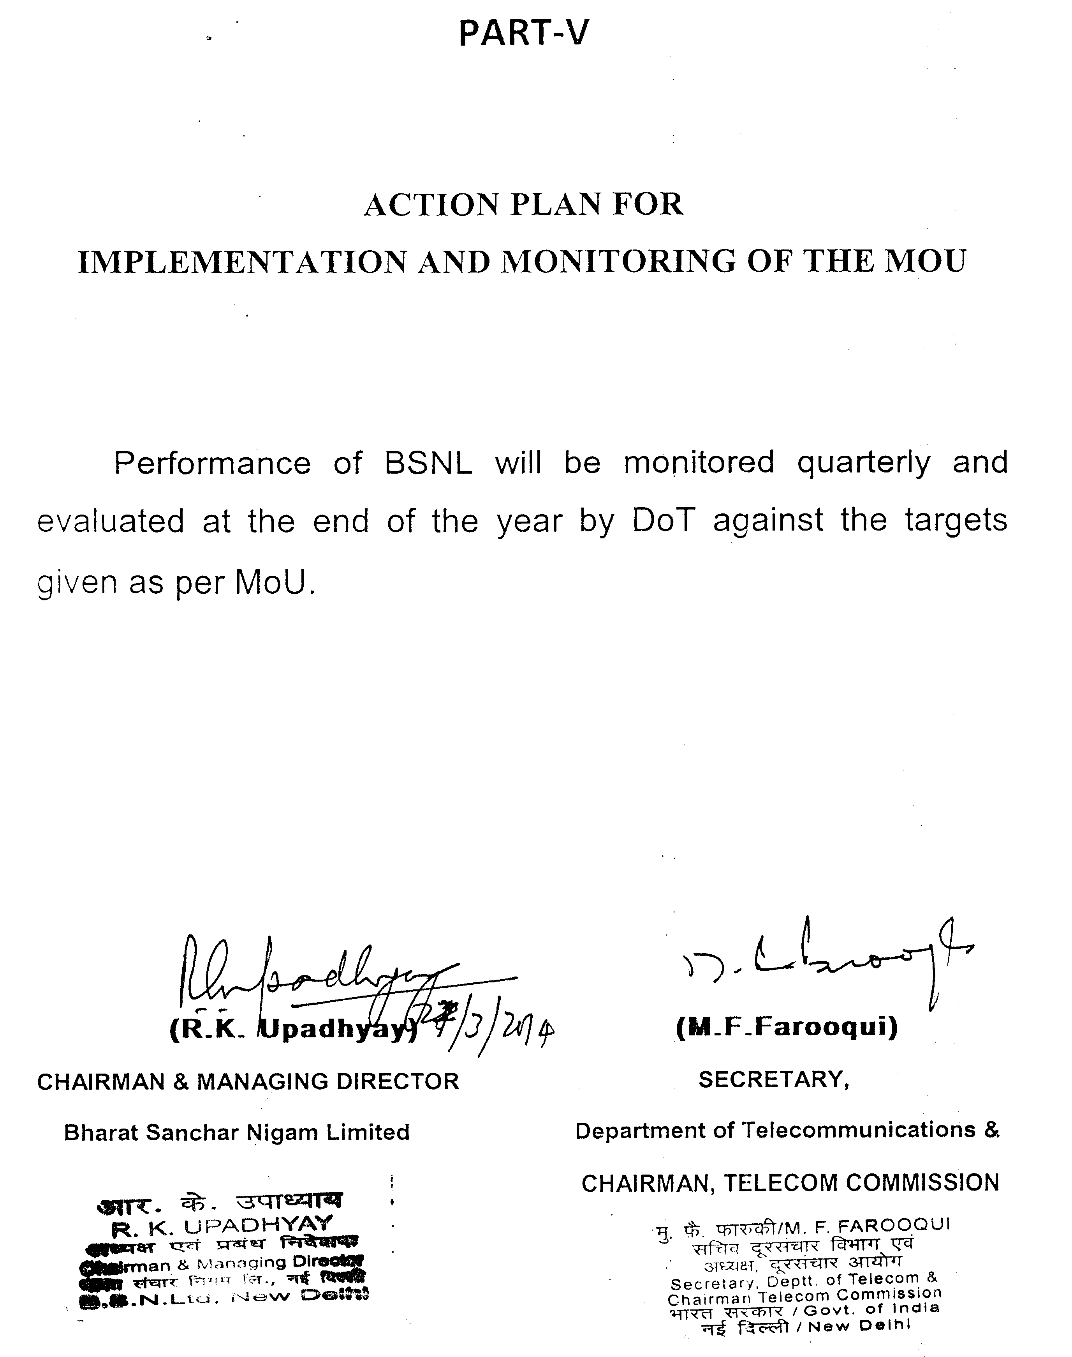

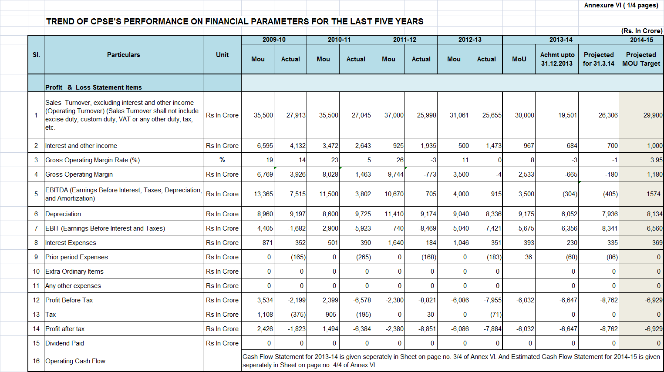
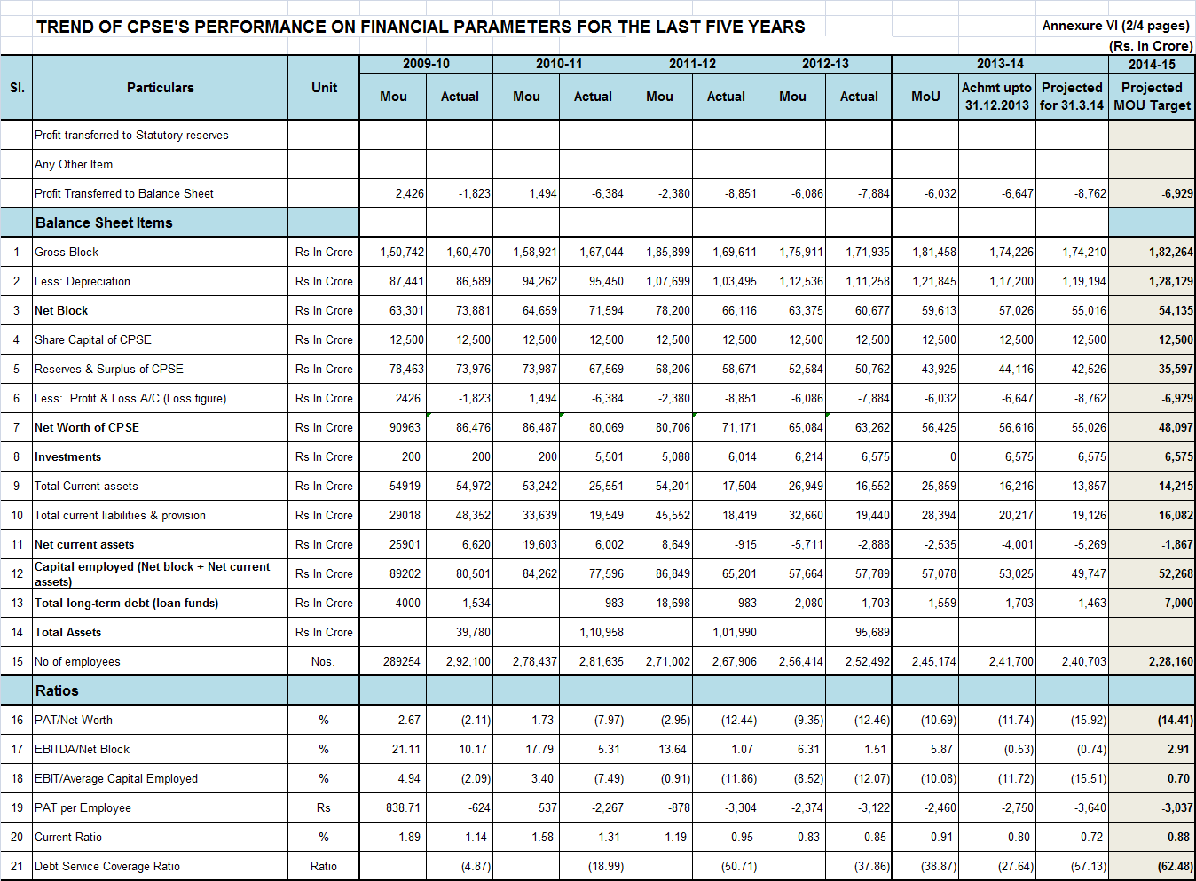
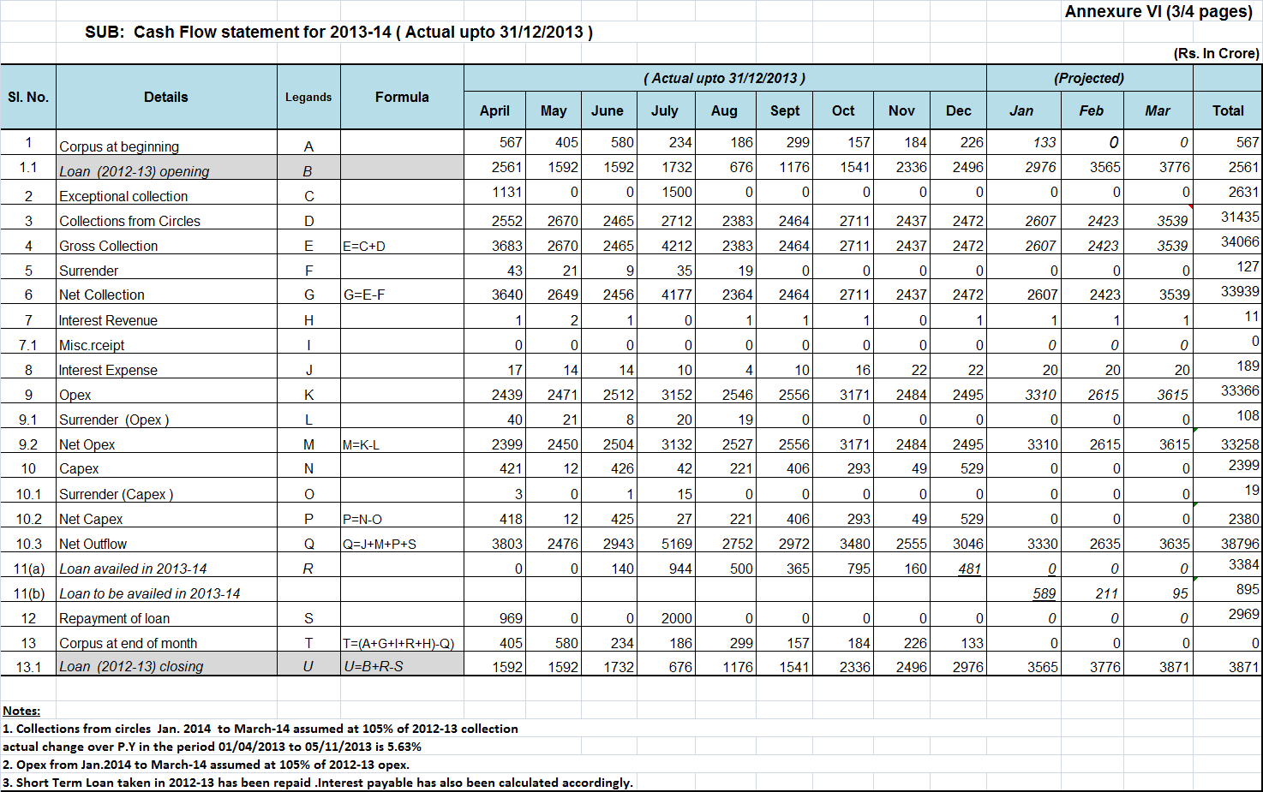
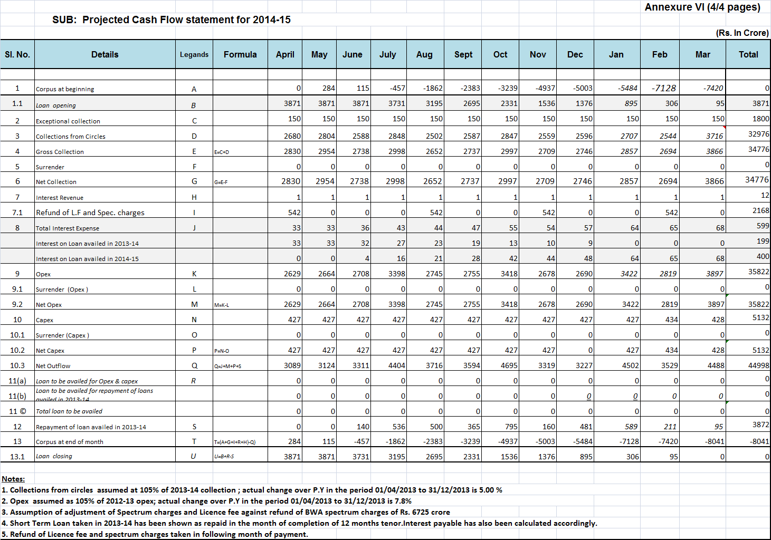
Annexure VII


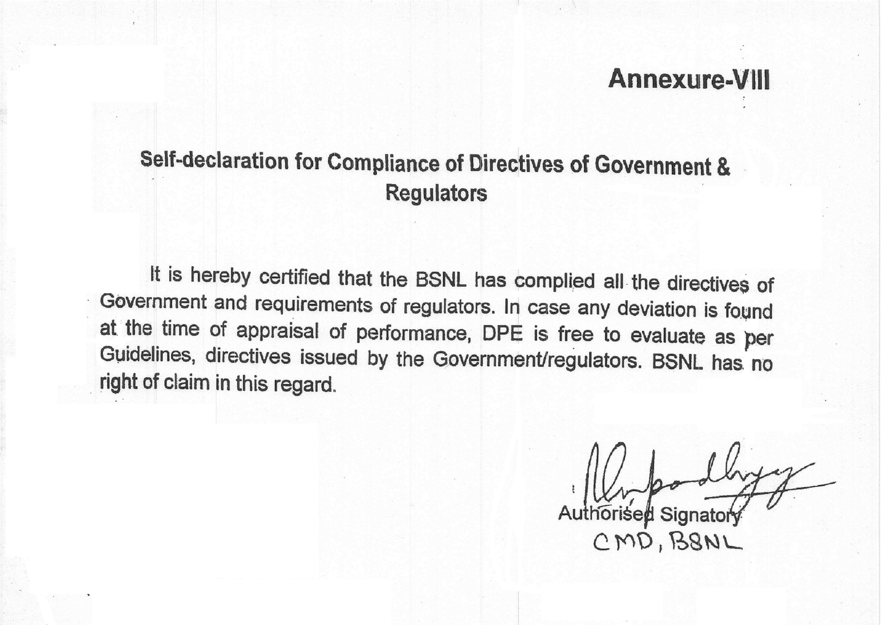

 |  | Annexure A
Quality of Service Performance of Wireline (Basic) Services
( Annexure A-I )
Sno. | Name of Parameter | TRAI Benchmark | Achmt
1 | Fault incidences (No. of faults/ 100 subscribers / month) | <= 5
Faults repaired
2 | For urban areas
 | By next working day | >= 90 %
 | within 3 days | 100 %.
3 | For rural and hilly areas
 | By next working day | >=90 %
 | within 5 days | 100%
4 | Rent Rebate
(a) | Faults pending for >3 days and =<7 days: | Rent rebate for 7 days.
(b) | Faults pending for >7 days and =<15 days | Rent rebate for 15 days.
(c) | Faults pending for >15 days | Rent rebate for one month
5 | Mean Time To Repair (MTTR) | =< 8 Hrs
6 | Call Completion Rate within a local network | >= 55 %
7 | Point of Interconnection (POI) Congestion (on individual POI) | < =0.5 %
8 | Metering and billing credibility - post paid | Not more than 0.1% of bills issued should be disputed over a billing cycle
9 | Resolution of billing/ charging complaints within 4 weeks | 100%
¹⁰ | Period of applying credit/ waiver/ adjustment to customer's account from the date of resolution of complaints | within 1 week
11 | Response Time to the customer for assistance
(a) | Accessibility of call centre/ customer care | >= 95 %
(b) | Percentage of calls answered by the operators (voice to voice) within 60 seconds | >= 90 %
12 | %age request for Termination/ closure of service compiled within 7 days | 100%
13 | Time taken for refund of deposits after closures within 60 days | 100%

Performance of Quality of Service(QoS) parameters for Cellular Mobile Services
(Annexure A-II)
SNo. | Name of Parameter | TRAI Benchmark | Achmt
A | Network Related Parameters:
 | Network Availability
1 | BTSs Accumulated downtime (not available for service) (%age) | =< 2 %
2 | Worst affected BTSs due to downtime (%age) | =< 2 %
 | Connection Establishment (Accessibility)
3 | Call Set-up Success Rate (within licensee's own network) | >= 95 %
4 | SDCCH/ Paging Channel Congestion (%age) | =< 1 %
5 | TCH Congestion (%age) | =< 2 %
 | Connection Maintenance (Retainability)
6 | Call Drop Rate (%age) | =<2 %
7 | Worst affected cells having more than 3% TCH drop (call drop) rate (%age) | =< 3 %
8 | Connections with good voice quality (%age) | >= 95 %
9 | Point of Interconnection (POI) Congestion (No. of POIs not meeting the benchmark) (Average over a period of Quarter) | =< 0.5 %
B | Customer Service Quality Parameters:
10 | Metering and billing credibility - post paid (Not more than 0.1% of bills issued should be disputed over a billing cycle) | =< 0.1 %
11 | Metering and billing credibility — pre-paid (Not more than 1 complaint per 1000 customers i.e. 0.1% complaints for metering, charging, credit, and validity) | =< 0.1 %
12 | Resolution of billing/ charging/ validity complaints | 100 % within 4 weeks
13 | Period of applying credit/ waiver/ adjustment to customer's account from the date of resolution of complaints | within 1 week of resolution of complaint
 | Response Time to the customer for assistance
14 | Accessibility of call centre/ customer care | >= 95 %
15 | Percentage of calls answered by the operators (voice to voice) within 60 seconds | >= 90 %
16 | %age requests for Termination/ Closure of service compiled | 100% within 7 days
17 | Time taken for refund of deposits after closures | 100% within 60 days

Quality of Service Performance of Broadband Services
(Annexure A-III )
Sno. | QoS Parameters | TRAI Benchmarks | Achmt
Service Provisioning /Activation Time
1 | %age of connections provided within 15 days of registration of demand | 100%
 | Fault Repair / Restoration Time
2 | % of faults repaired by next working day | >=90 %
3 | % of faults repaired within 3 working day | >= 99 %
 | Billing performance
4 | Rent Rebate | In Nos
4a) | Faults Pending for >= 3 working days and <= 7 working days: | rebate equivalent to 7 days of minimum monthly charge or equivalent usage allowance
4b) | Faults Pending for >= 7 working days and =< 15 working days | rebate equivalent to 15 days of minimum monthly charge or equivalent usage allowance
4c) | Faults Pending for >= 15 working days | rebate equivalent to one month of minimum monthly charge or equivalent usage allowance
5 | %age of bills disputed | =< 2 %
6 | %age of billing complaints resolved within 4 weeks | 100%
 | Response time to the customer for assistance
7 | % age of calls answered by operator (Voice to Voice) within 60 seconds | >= 60%
8 | % age of calls answered by operator (Voice to Voice) within 90 seconds | >= 80%
 | Bandwidth Utilization/ throughput
9 | No. of Intra-network links having bandwidth utilization >90% during peak hours ( TCBH) | 0
10 | % International bandwidth utilization during peak hours (TCBH) (Enclose MRTG) < 90% | =< 90 %
11 | Bandwidth connection speed available (download) from ISP node to user | >= 80 %
12 | Service Availability / Uptime (for all users) in %age | >= 98 %
13 | Packet loss( for wired broadband access) in %age | =< 1%
 | Network Latency (for wired broadband access)
14 | User reference point at POP / ISP Gateway node to International Gateway (IGSP/NIXI) | =< 120 msec
15 | User reference point at ISP Gateway node to International nearest NAP port abroad (Terrestrial) | =< 350 msec

Annexure B
Means for Measuring the Performance of Dynamic/ Non-Financial Parameters:
The means for measuring the performance of Non-Financial Parameters along with source/origin of information
Sl.No | Parameters which are to be measured | Means for measuring the achievement
2 (i) | Initiative for growth
a) | Corporate/ Strategic plan-preparation/ determination/ Identification of objectives / goals | BSNL has hired the services of a strategic consultant, M/s Deloitte Touche Tohmatsu India Pvt Limited, who shall have comprehensive study of BSNL and suggest revival plan of BSNL
(i) | Finalisation of Revival Plan of BSNL | CP&M cell is coordinating this activity in BSNL CO with the Consultant & take up the report within BSNL for consideration by the Management to take finalization of the same.
(ii) | Finalization of policy for Organizational Restructuring and Implementation during the year | The suggestions on Organizational restructuring from the consultant will be coordinated and taken up within BSNL by Restructuring Cell.
(iii) | Formulation of Policy for HR Restructuring | The suggestions on HR-restructuring from the consultant will be coordinated and taken up within BSNL for finalization by GM (Establishment).
(iv) | Submission of Implementation plan of restructuring of BSNL to DoT | The Organizational restructuring from the consultant will be coordinated and taken up within BSNL and onward submission to DoT by Restructuring Cell.
(v) | Formation of Subsidiary of BSNL Tower assets | GM (Infra sales) is coordinating the activity in BSNL CO and further in DOT
2 (ii) | Project Management & Implementation
a) | CAPEX for Capacity expansion
 | (i) Net addition in O.F. Cable in BSNL Network | Reports collected from Circles/Inspection Circle by CNP Cell of BSNL Corporate office and compiled on monthly basis.
 | (ii) Net addition in GSM capacity | Circles upload data on the Web based MIS portal and CMTS project Monitoring portal. Report is compiled and monitored by NWP-GSM cell of BSNL Corporate office on monthly basis.
 | Parameters which are to be measured | Means for measuring the achievement
 | (iii) Replacement of Legacy wire line exchanges by NGN | Reports from the circles in respect of replacement of Legacy Wire line network to NGN to the Corporate office will be collected and compiled by NWP-CFA Cell On monthly basis.
b) | Completion of New/ Ongoing projects during the year
 | - For Laying of O.F. Cable for Defence Project Network for Spectrum | Reports collected from Circles by CNP Cell of BSNL Corporate office and compiled on monthly basis.
 | - National Optical Fiber Network (NOFN) to connect Gram Panchayats (GPs) | Monthly reports from circles are compiled at NOFN cell of BSNL Corporate Office
 | - Commissioning of GSM BTSs to provide Mobile coverage in Left Wing Extremist (LWE) areas | Monthly reports of GSM BTS commissioning are compiled at NWO-CM cell of BSNL Corporate Office.
2 (iii) | Productivity and Internal Process
a) | ARPU for GSM Services of BSNL w.r.t Industry average | Financial Cell in mobile wing of BSNL CO is prepared this data on monthly basis which can be used for the purpose of measuring the performance.
b) | Telecom Network Utilization/ Downtime - Quality of service & Customer Satisfaction parameters:
 | - Wireline Basic services | The TRAI parameters are monitored in BSNL on regular basis in each Circle. A consolidated report is prepared by NWO-CFA, Fin-CFA & CS Cell of CFA l in BSNL CO and sent to TRAI.
 | - Cellular Mobile Services | The TRAI parameters are monitored in BSNL on regular basis in each Circle. A consolidated report is prepared by NWO-CM, Fin-CM & CSC Cell of CM in BSNL CO and sent to TRAI.
 | - Broadband Services | The TRAI parameters are monitored in BSNL on regular basis in each Circle. A consolidated report is prepared by NWO-BB &IN, Fin-CFA & CSC Cell of BB in BSNL CO and sent to TRAI.
 | Parameters which are to be measured | Means for measuring the achievement
2 (iv) | Human Resource Management
 | (i) Executive Development training program  (ii) Skill Development Training for Non-executives  (ii) Management Training program courses for senior/middle management Personnel | Measurement of training parameters is being done on the basis of information uploaded by Training centers in an online database CTMS (Computerized Telecom Monitoring System)and a quarterly report is compiled in Training cell of BSNL CO New Delhi.
3 (i) | Net addition in GSM Mobile connections | GSM mobile connections data is collected from HLR from circles/SSAs and uploaded on web based MIS portal and CMTS project monitoring portal. NWP-GSM & CDN cell at BSNL CO. New Delhi monitors the data generate the Reports on monthly & quarterly basis.
3 (ii) | Net Addition in Broadband Connections | A monthly MIS is being generated from four CDR data Centers spread across the country. The data is compiled on monthly basis and monthly report is generated by NWP- BB cell at BSNL CO. New Delhi.
3 (iii) | The number of Territorial Circles where ERP is to be implemented | GM (C IT ) is Coordinating & Compiling report in BSNL CO
3 (iv) | Synergy between BSNL and MTNL | On actual basis of settlement of Issues by both CPSEs
3 (v) | Settlement of C & AG Report Paras | GM (Internal Audit) is coordinating & preparing the reply to the Audit Paras of the C &AG report
3 (vi) | Reduction in Statutory Audit Paras | GM (Corp. Accounts) is replying to the statutory Audit Paras in BSNL CO.

*BSNL CO - BSNL Corporate Office

